FARM MANAGEMENT SYSTEM

User Story
The Farm Management System (FMS) is intended to give farmers, farm managers, and system administrators a single Salesforce-based workspace where farm, crop, farmer, and buyer information can be captured and maintained. The goal is to keep all agricultural data stored in a secure, well-organized manner. Users should be able to add and revise farm details, crop production entries, and buyer transactions through an intuitive interface, with validation safeguards in place to stop faulty data from being saved. The platform should additionally produce live reports and interactive dashboards, so users can study farm output, keep an eye on sales, and act on reliable information. Role-based permissions and protected storage are also required, so that confidential data stays safe while still allowing users to work together smoothly. In the end, the system is meant to cut down on manual paperwork, shrink the number of mistakes, raise overall efficiency, and encourage farm management driven by data.

1. INTRODUCTION

1.1 Project Overview
The Farm Management System (FMS) is an application built on Salesforce, aimed at converting agricultural operations into digital, streamlined processes. It keeps track of information about farms, crops, farmers, and buyers, while also delivering live insights via reports and dashboards. This enables farmers and managers to follow agricultural activity closely and take well-grounded decisions.

1.2 Purpose
The project sets out to achieve the following:
- Convert agricultural record-keeping into a digital format
- Boost the accuracy and reachability of data
- Take over routine record handling through automation
- Allow monitoring to happen in real time
- Back farming decisions with solid data
- Raise both productivity and openness

2. IDEATION PHASE

2.1 Problem Statement (Customer Problem Statement Template)
PS | I am  (Customer) | I'm trying to | But | Because | Which makes me feel
PS-  1 | Farmer | Maintain farm and crop records | Data is often incomplete or incorrect | Records are kept manually in registers | Frustrated and confused
PS-  2 | Farm  Manager | Monitor farm productivity and sales | Reports are delayed and inaccurate | Data is scattered across files and sheets | Stressed and inefficient
PS-  3 | Buyer | Access crop availability and pricing | Information is not updated regularly | There is no centralized digital system | Uncertain and dissatisfied
PS-  4 | System  Admin | Manage user access and system security | Unauthorized access may occur | Access control is handled manually | Concerned and insecure
PS-  5 | System  Admin | Track data changes and audit records | Change history is incomplete | Auditing is done manually | Exposed and worried
PS-  6 | Buyer | Track order and delivery status | Status updates are unclear | Updates are shared manually | Anxious and dissatisfied

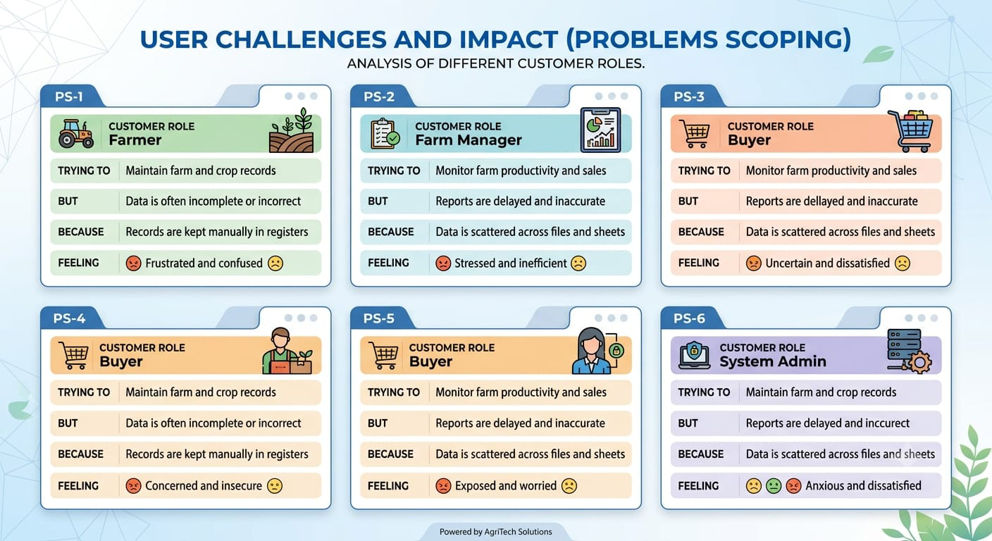

2.2 Empathy Map Canvas
Target Users:
- Farmers
- Farm Managers
- Buyers
- System Administrators
Empathy Analysis
- Think & Feel: Need accurate and timely farm data
- Hear: Feedback from agricultural officers
- See: Registers, paper files, spreadsheets
- Say & Do: Enter records manually
- Pain: Data loss, errors, delays
- Gain: Automation, fast reporting
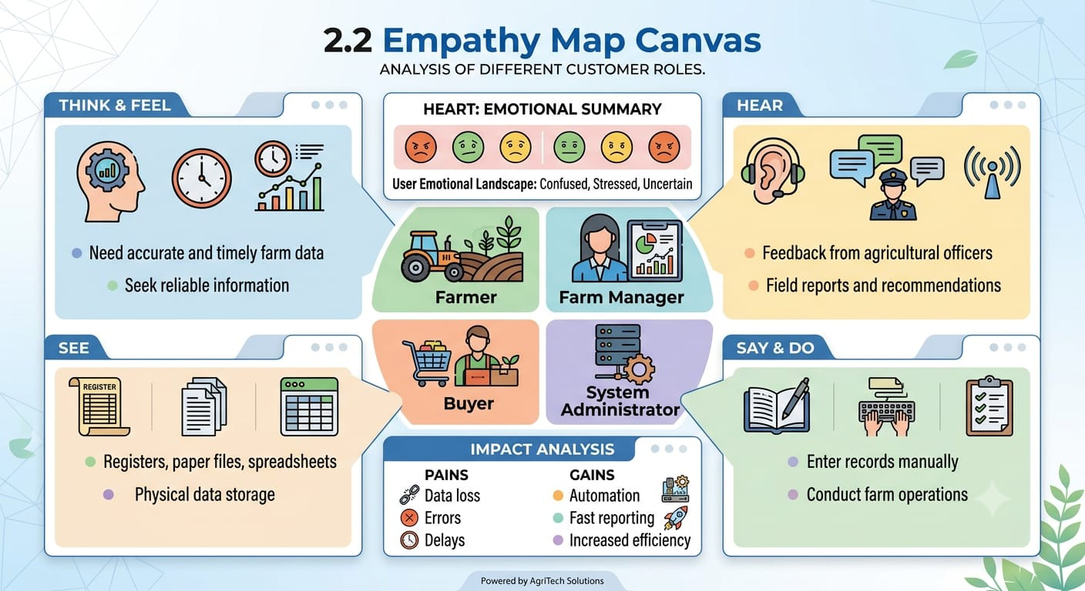

2.3 Brainstorming
Brainstormed Ideas
- Records maintained on paper
- Tracking through spreadsheet tools
- Desktop-only farm management software
- A bespoke web portal for farms
- A mobile-first farming application
- Adapting a cloud CRM such as Salesforce
- A smart farming setup powered by IoT devices
- Crop traceability built on blockchain Selected Idea
Salesforce-based Farm Management System.

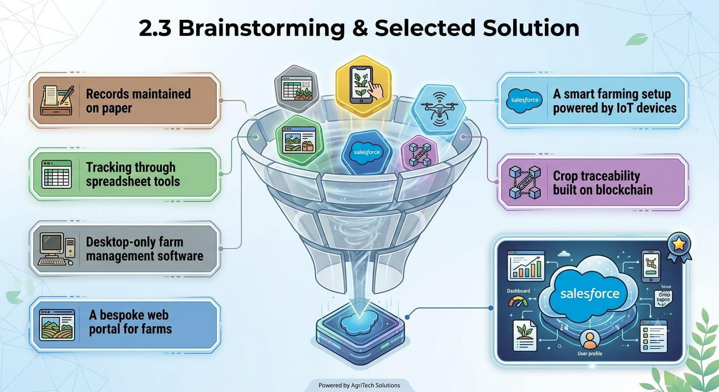

3. REQUIREMENT ANALYSIS PHASE

3.1 Customer Journey Map
Stages:
- Login
- Access Farm Management App
- Enter Farm and Crop Data
- Register Farmers and Buyers
- Generate Reports
- Analyze Results
- Decision Making
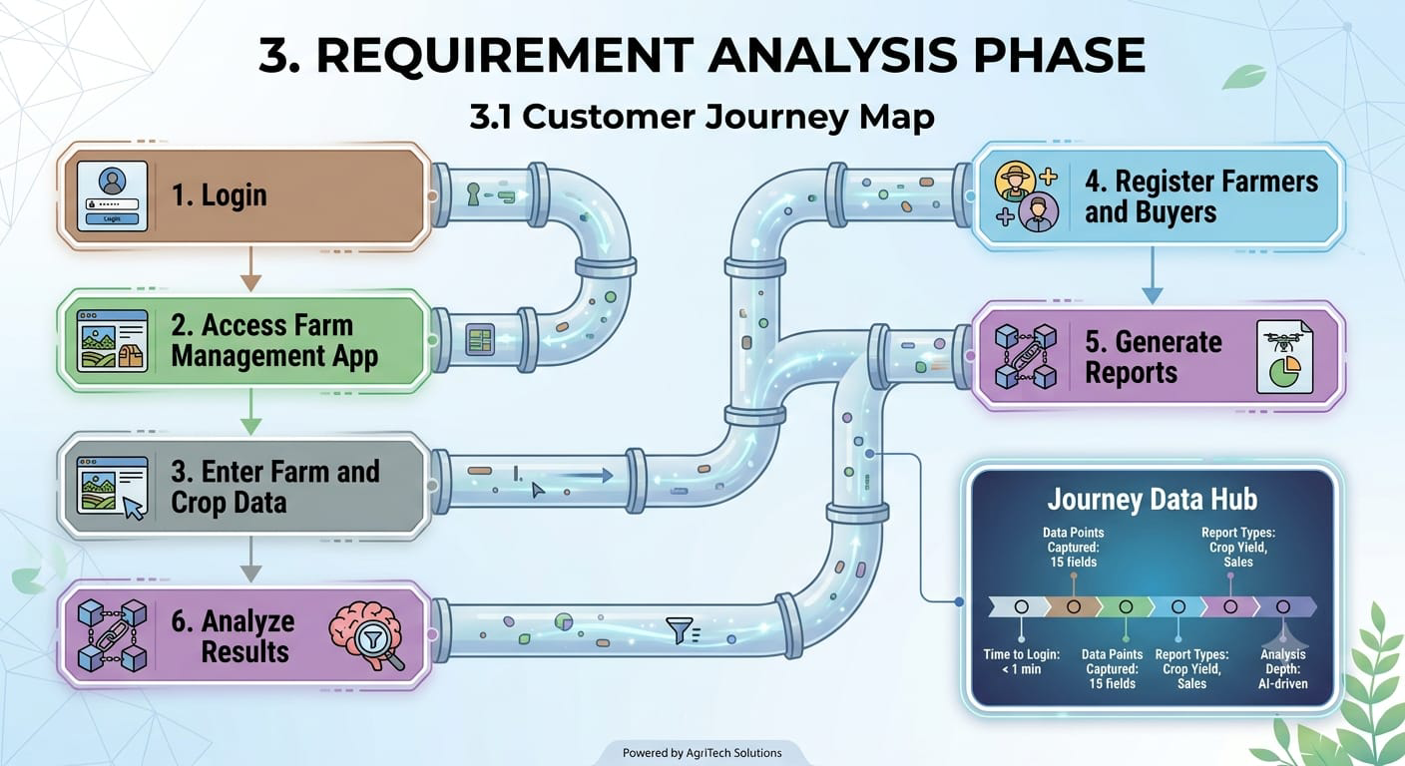

3.2 Solution Requirements
Functional Requirements
FR No | Requirement
FR-1 | User Authentication
FR-2 | Farm, Crop, Farmer, Buyer Management
FR-3 | Data Entry and Validation
FR-4 | Relationship Mapping
FR-5 | Report Generation
FR-6 | Dashboard Visualization
FR-7 | User Role Management
FR-8 | Notification and Alerts
FR-9 | Data Backup and Recovery
FR-10 | Audit Trail and History Tracking
Non-Functional Requirements
NFR | Description | Example
Usability | Easy interface | Simple Lightning UI
Security | Data protection | Profiles & roles
Reliability | No data loss | Cloud backup
Performance | Fast access | Reports in <3 sec
Availability | 24/7 access | Cloud hosting
Scalability | Handles growth | More farms/users
Maintainability | Easy to update and modify | Declarative configuration
Compliance | Meets agricultural data standards | GDPR / local data laws

3.3 Data Flow Diagram
Data Flow:
User → Salesforce UI → Custom Objects (Farm, Crop, Farmer, Buyer) → Validation Rules →
Relationships → Reports → Dashboards
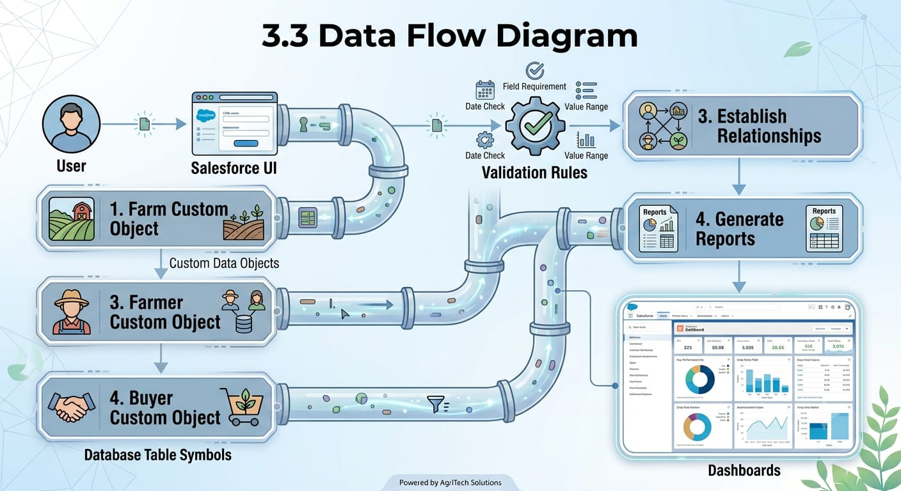

3.4 Technology Stack
Layer | Technology
Frontend | Salesforce Lightning UI
Backend | Salesforce Platform
Database | Salesforce Cloud
Automation | Validation Rules
Analytics | Reports & Dashboards

4. PROJECT DESIGN PHASE

4.1 Problem–Solution Fit
The FMS replaces handwritten farm records with automated data handling. Storing everything in the cloud removes the risk of losing data, dashboards make analysis sharper, and live reports do away with waiting times. What emerges is agricultural information that is both accurate and available on demand.
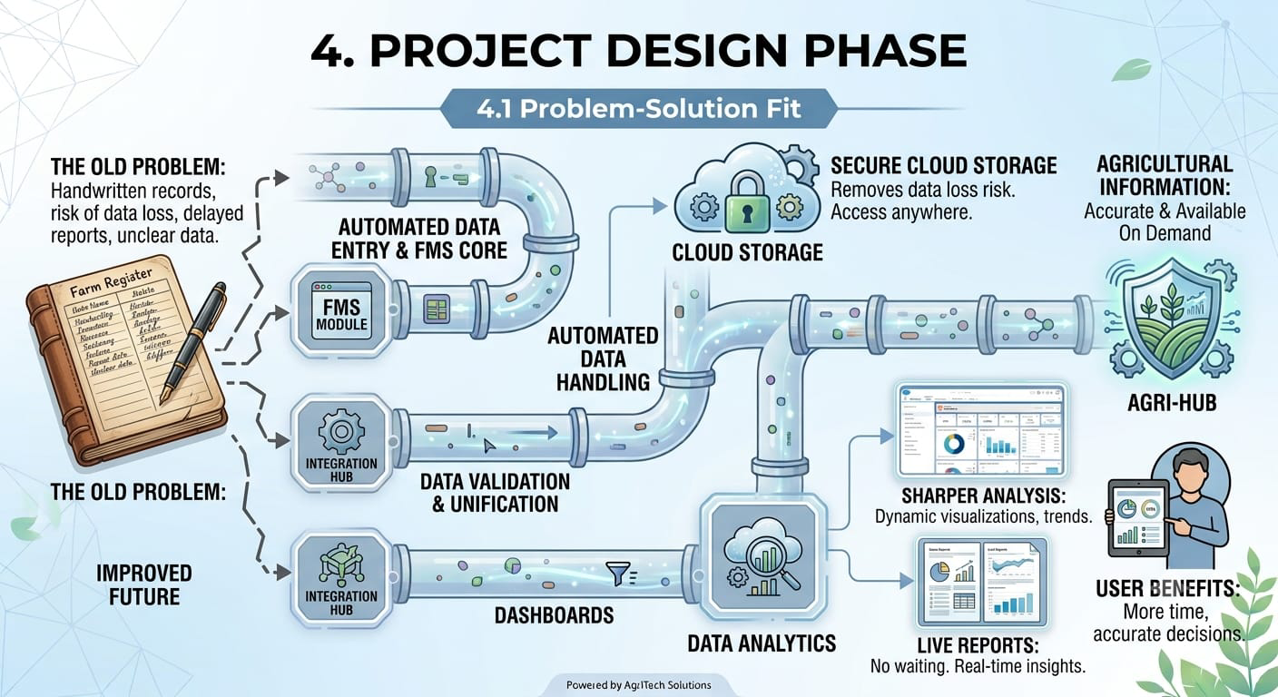

4.2 Proposed Solution
The Farm Management System responds to the weaknesses of traditional record-keeping by delivering a single, cloud-hosted alternative. Each element of the solution is described below.
The Problem
Records for farms, crops, farmers, and buyers are currently written out by hand. Such a method invites mistakes, leaves data open to being lost, and slows down access to critical information.
The Solution
A Salesforce-driven Farm Management System that brings all agricultural data into one place and automates routine record handling.
The Innovation
Automated checks at the moment of data entry, safe cloud storage, and dashboards that report in real time — none of which exist in manual or spreadsheet-based approaches.
The Impact
Farmers and managers can rely on information that is accurate and current. Reports are produced faster, and decisions become better informed.
The Business Model
The platform serves as a digital farm management and agricultural data services offering.
Scalability
Because it rests on cloud infrastructure, the system can absorb more farms, users, and regions with minimal rework.

4.3 Solution Architecture
Architecture Layers
- Presentation Layer – Salesforce Lightning UI
- Application Layer – Validation Rules, Relationships
- Data Layer – Custom Objects
- Analytics Layer – Reports and Dashboards
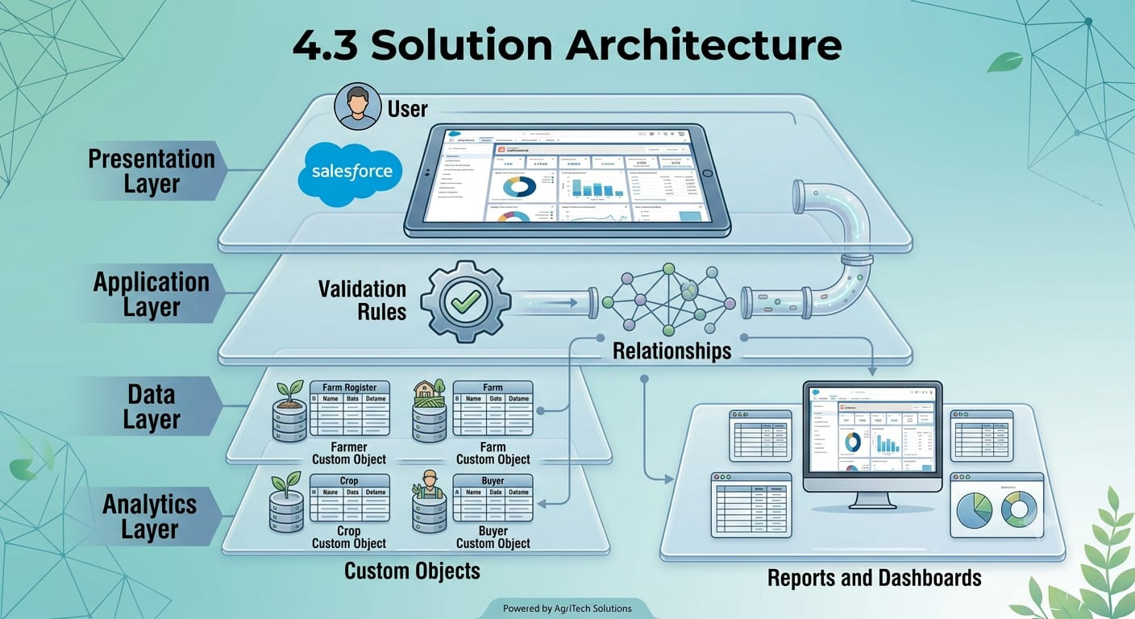

5. PROJECT PLANNING & SCHEDULING

5.1 Project Planning
- Created Salesforce Developer Org
- Developed custom objects
- Configured tabs and Lightning App
- Created fields and relationships
- Designed profiles and roles
- Created users and sharing rules
- Developed reports and dashboards
- Conducted testing and reviews
Product Backlog, Sprint Schedule, and Estimation
Sprint | Functional  Requirement  (Epic) | User  Story  Number | User Story / Task | Story  Points | Priority | Team  Members
Sprint-  1 | User Story | USN-1 | As a user, I want to understand the overall system story so that I know the scope of the FMS. | 3 | High | Member 1
Sprint-  1 | Salesforce  Account  Creation | USN-2 | As a system administrator, I want to create a Salesforce Developer Org so that I can set up and deploy the FMS. | 8 | High | Member 1
Sprint-  1 | Salesforce  Account  Creation | USN-3 | As a system administrator, I want to activate my Salesforce account so that I can log in and access the platform. | 3 | High | Member 1

Sprint-  2 | Objects | USN-4 | As an admin, I want to create a custom object for Farm so that farm data is stored systematically. | 1 | High | Member 2
Sprint-  2 | Objects | USN-5 | As an admin, I want to create a custom object for Crop so that crop data can be recorded. | 1 | High | Member 2
Sprint-  2 | Objects | USN-6 | As an admin, I want to create a custom object for Farmer so that farmer details can be maintained. | 1 | High | Member 2
Sprint-  2 | Objects | USN-7 | As an admin, I want to create a custom object for Buyer so that buyer information can be tracked. | 1 | High | Member 2
Sprint-  3 | Tabs | USN-8 | As a staff member, I want a Farm tab so that I can quickly access farm records. | 1 | High | Member 3
Sprint-  3 | Tabs | USN-9 | As a staff member, I want a Crop tab so that I can quickly access crop records. | 1 | High | Member 3
Sprint-  3 | Tabs | USN-10 | As a staff member, I want a Farmer tab so that I can quickly access farmer records. | 1 | High | Member 3
Sprint-  3 | Tabs | USN-11 | As a staff member, I want a Buyer tab so that I can quickly access buyer records. | 1 | High | Member 3

Sprint-  4 | Lightning App | USN-12 | As a staff member, I want a Lightning App with all farm modules so that I can navigate and perform daily operations easily. | 5 | High | Member 1
Sprint-  5 | Fields and  Relationship | USN-13 | As an admin, I want to create fields for the Farm object so that complete farm details can be captured. | 1 | High | Member 5
Sprint-  5 | Fields and  Relationship | USN-14 | As an admin, I want to create fields for the Crop object so that complete crop details can be captured. | 1 | High | Member 5
Sprint-  5 | Fields and  Relationship | USN-15 | As an admin, I want to create fields for the Farmer object so that complete farmer details can be captured. | 1 | High | Member 5
Sprint-  5 | Fields and  Relationship | USN-16 | As an admin, I want to create fields for the Buyer object so that complete buyer details can be captured. | 1 | High | Member 5
Sprint-  6 | Profile | USN-17 | As an administrator, I want to create a custom profile so that user permissions can be controlled. | 1 | High | Member 2
Sprint-  6 | Profile | USN-18 | As an administrator, I want to create a second custom profile so that different user groups get distinct access. | 1 | High | Member 2

Sprint-  6 | Role | USN-19 | As an administrator, I want to create a role so that the reporting hierarchy is defined. | 1 | High | Member 2
Sprint-  6 | Users | USN-20 | As an administrator, I want to create a user so that team members can log in and use the system. | 1 | High | Member 4
Sprint-  6 | Users | USN-21 | As an administrator, I want to create a Sales Department user so that sales staff can access relevant records. | 1 | High | Member 4
Sprint-  7 | Sharing Rules | USN-22 | As an administrator, I want to create a sharing rule so that records are shared based on conditions. | 1 | High | Member 3
Sprint-  7 | Sharing Rules | USN-23 | As an administrator, I want to share Buyer records with the Sales department with  Read/Write access. | 1 | High | Member 3
Sprint-  7 | User Adoption | USN-24 | As a staff member, I want to create a Farmer record so that I can verify the system works end-to-end. | 1 | High | Member 3
Sprint-  8 | Reports | USN-25 | As a farm manager, I want to create a report so that I can view farmer and farm data together. | 1 | High | Member 3
Sprint-  8 | Reports | USN-26 | As a farm manager, I want to create a report using Crops and Buyers so that I can analyse related data. | 1 | High | Member 3
Sprint-  8 | Dashboard | USN-27 | As a farm manager, I want to create a dashboard so that I can monitor performance visually. | 2 | Medium | Member 2
Sprint-  8 | View Report and Dashboard | USN-28 | As a farm manager, I want to view the report so that I can review the records. | 1 | Medium | Member 1
Sprint-  8 | View Report and Dashboard | USN-29 | As a farm manager, I want to view the dashboard so that I can review summarised data. | 1 | Medium | Member 1
Project Tracker, Velocity & Burndown Chart
Sprint | Total  Story  Points | Duration | Sprint  Start Date | Sprint End  Date  (Planned) | Story Points  Completed (as on  Planned End Date) | Sprint  Release Date  (Actual)
Sprint-  1 | 14 | 1 Day | 16 Sep  2026 | 16 Sep 2026 | 14 | 16 Sep 2026
Sprint-  2 | 4 | 1 Day | 17 Sep  2026 | 17 Sep 2026 | 4 | 17 Sep 2026
Sprint-  3 | 4 | 1 Day | 18 Sep  2026 | 18 Sep 2026 | 4 | 18 Sep 2026
Sprint-  4 | 5 | 1 Day | 19 Sep  2026 | 19 Sep 2026 | 5 | 19 Sep 2026
Sprint-  5 | 4 | 1 Day | 20 Sep  2026 | 20 Sep 2026 | 4 | 20 Sep 2026
Sprint-  6 | 5 | 1 Day | 21 Sep  2026 | 21 Sep 2026 | 5 | 21 Sep 2026
Sprint-  7 | 3 | 1 Day | 22 Sep  2026 | 22 Sep 2026 | 3 | 22 Sep 2026
Sprint-  8 | 6 | 2 Days | 23 Sep  2026 | 24 Sep 2026 | 6 | 24 Sep 2026

6. PROJECT DEVELOPMENT PHASE

Project Description
The Farm Management System (FMS), built on Salesforce, is a full-scale solution meant to take agricultural operations digital and make them more efficient. It gives farmers, farm managers, and other stakeholders the means to manage data on crops, farms, farmers, and buyers, while also providing useful insight through reports and dashboards.

Milestone 1 – Salesforce
What Is Salesforce?
Salesforce serves as a customer success platform, built to help you sell, service, market, analyze, and connect with customers. It packs in everything needed to run a business from any location. Through its standard products and features, you can handle relationships with prospects and customers, work alongside employees and partners, and keep data safely stored in the cloud.

Activity 1: Creating a Salesforce Developer Org
A Developer org ships with every feature and license required to begin working with Salesforce.
- Open Developer.salesforce.com/signup
- Provide the required details — First name, last name, Email, Role, Company, Country/Region, Postal code, and a Username that has to be unique.
- Hit "sign me up." Within a few minutes a mail from Salesforce will arrive; follow the verify account link to set a new password.
- Click save.
- Open login.salesforce.com
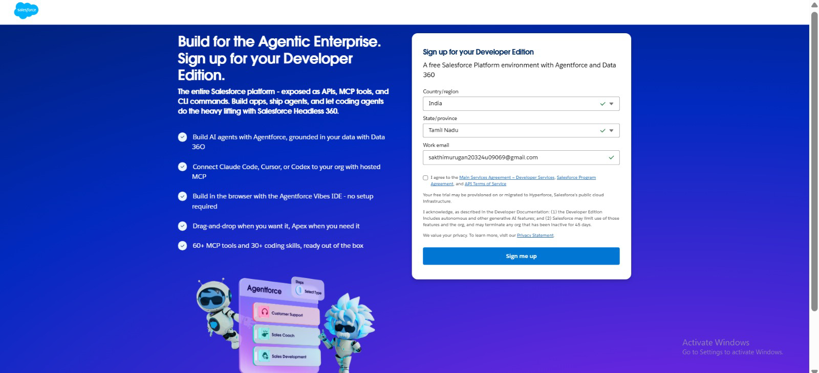
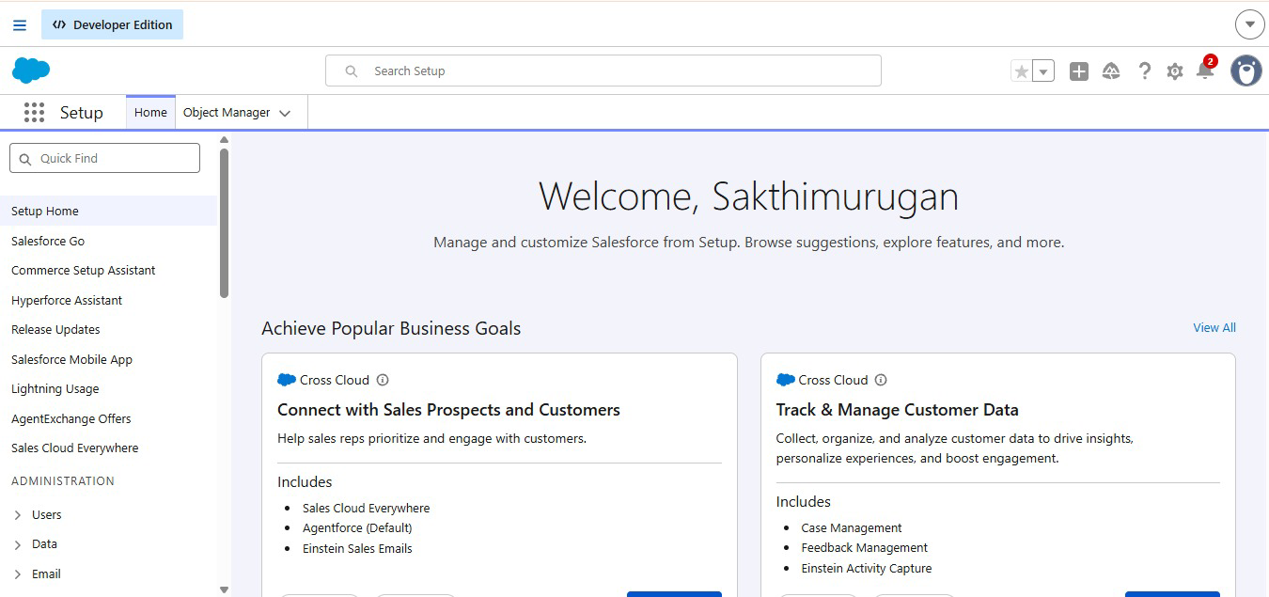
- Sign in using your username and password to reach the Salesforce org. The homepage will show up as illustrated below.

Milestone 2 – Object
What is an object?
Salesforce objects function as database tables, allowing you to hold data that belongs to an organization.
Every object is made up of fields (columns) and records (rows).
Four custom objects are used in this application:
- Farm
- Crop
- Farmer
- Buyer

Activity 1: Create a custom object for Farm
To build a custom object, carry out these steps:
- In Setup, click Object Manager.
- Click Create, then pick Custom Object.
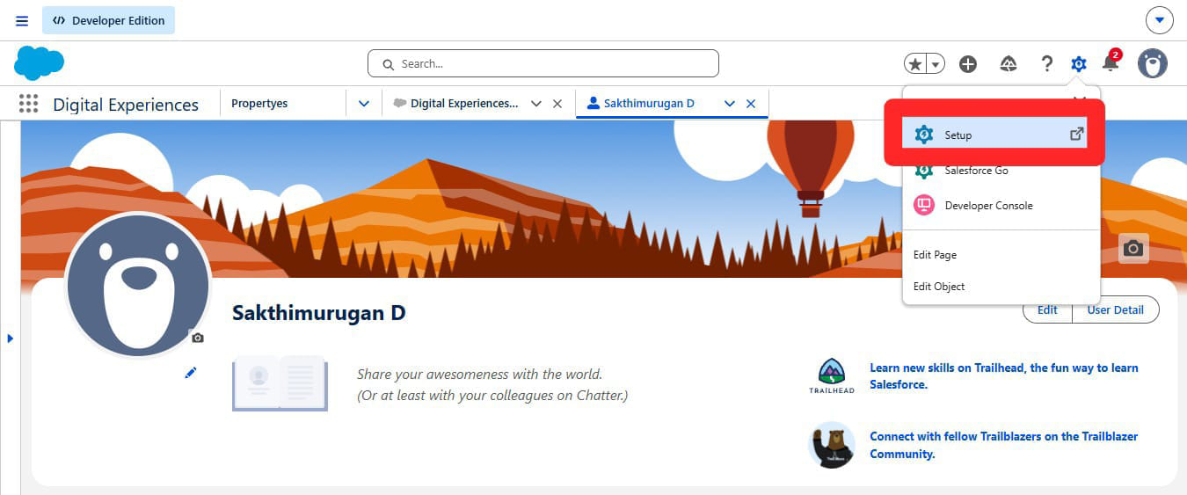
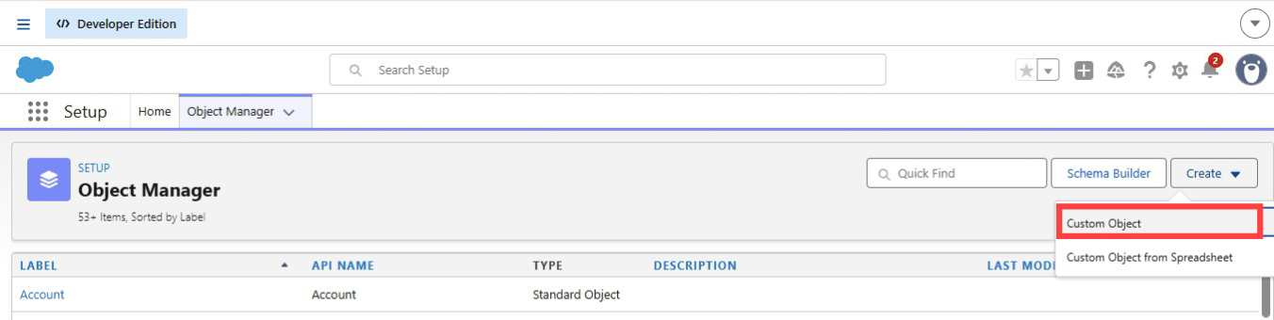
- Put the label as "Farm".
- Put the plural label as "Farms".
- Record name: "Farm Name".
- Pick the data type "Text".
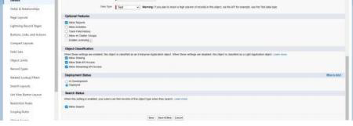
- Within Optional Features, mark Allow Reports and Track Field History.
- Within Deployment Status, confirm Deployed is chosen.
- Within Search Status, choose Allow Search.
- Within Object Creation Options, mark Add Notes and Attachments related list to default page layout.
- Keep the rest of the settings as they are and click Save.

Activity 2: Creation of Crop object
- Click the gear icon, then pick Setup.
- Click the Object Manager tab, sitting next to the Home tab.
- On the far right a Create dropdown will appear; click it and pick Custom Object.
a. On the Custom Object Definition page, set up the object as follows: b. Label: Crop
  - Plural Label: Crops
  - Record Name: Crop Name
  - Pick the data type "Text".
  - Mark the Allow Reports checkbox.
  - Mark the Allow Search checkbox.
  - Within Object Creation Options, mark Add Notes and Attachments related list to default page layout.
  - Click Save.

Activity 3: Creation of Farmer object
- Click the gear icon, then pick Setup.
- Click the Object Manager tab, sitting next to the Home tab.
- On the far right a Create dropdown will appear; click it and pick Custom Object.
  - On the Custom Object Definition page, set up the object as follows:
  - Label: Farmer
  - Plural Label: Farmers
  - Record Name: Farmer Name
  - Pick the data type "Text".
  - Mark the Allow Reports checkbox.
  - Mark the Allow Search checkbox.
  - Within Object Creation Options, mark Add Notes and Attachments related list to default page layout.
  - Click Save.

Activity 4: Creation of Buyer object
- Click the gear icon, then pick Setup.
- Click the Object Manager tab, sitting next to the Home tab.
- On the far right a Create dropdown will appear; click it and pick Custom Object.
a. On the Custom Object Definition page, set up the object as follows: b. Label: Buyer
  - Plural Label: Buyers
  - Record Name: Buyer Name
  - Pick the data type "Text".
  - Mark the Allow Reports checkbox.
  - Mark the Allow Search checkbox.
  - Within Object Creation Options, mark Add Notes and Attachments related list to default page layout.
  - Click Save.

Milestone 3 – Tab
Tab
Tabs in Salesforce allow users to take in information at a glance. They show object data along with other web content inside the application.

Activity 1: Creation of Farm tab
Now build a custom tab.
- Click the Home tab, type "Tabs" into Quick Find, and pick Tabs.
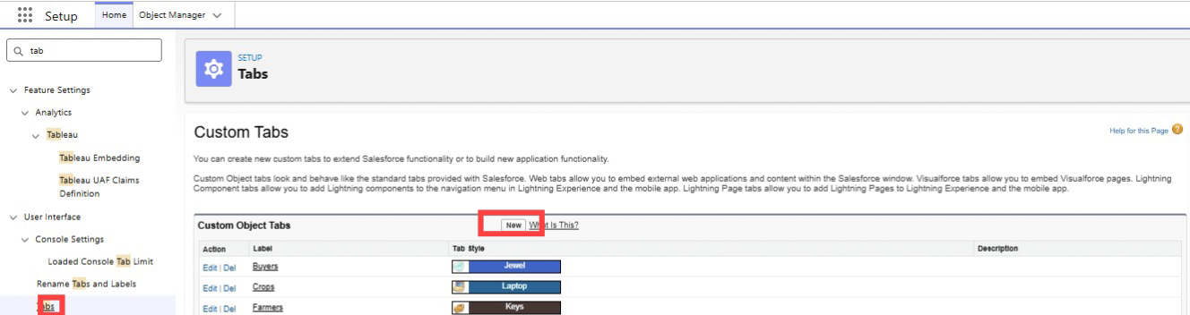
- Beneath Custom Object Tabs, click New.
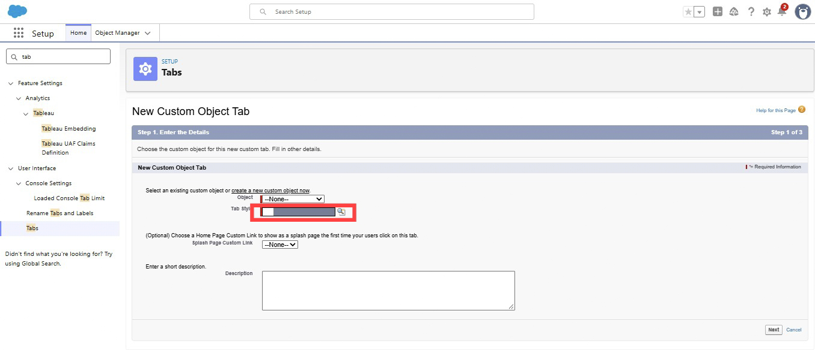

- For Object, pick Farm.
- For Tab Style, choose any icon.
- Leave all defaults untouched. Click Next, Next, and Save.

Activity 2: Creation of Crop tab
Now build a custom tab.
- Click the Home tab, type "Tabs" into Quick Find, and pick Tabs.
- Beneath Custom Object Tabs, click New.
- For Object, pick Crop.
- For Tab Style, choose any icon.
- Leave all defaults untouched. Click Next, Next, and Save.

Activity 3: Creation of Farmer tab
Now build a custom tab.
- Click the Home tab, type "Tabs" into Quick Find, and pick Tabs.
- Beneath Custom Object Tabs, click New.
- For Object, pick Farmer.
- For Tab Style, choose any icon.
- Leave all defaults untouched. Click Next, Next, and Save.

Activity 4: Creation of Buyer tab
Now build a custom tab.
- Click the Home tab, type "Tabs" into Quick Find, and pick Tabs.
- Beneath Custom Object Tabs, click New.
- For Object, pick Buyer.
- For Tab Style, choose any icon.
- Leave all defaults untouched. Click Next, Next, and Save.

Milestone 4 – Lightning App
What is an App?
In Salesforce, an app refers to a set of tabs that operate together as one unit. It has a name, a logo, and its own particular set of tabs. The most basic app usually contains just two tabs.

Activity 1: Create the Farm Management System app
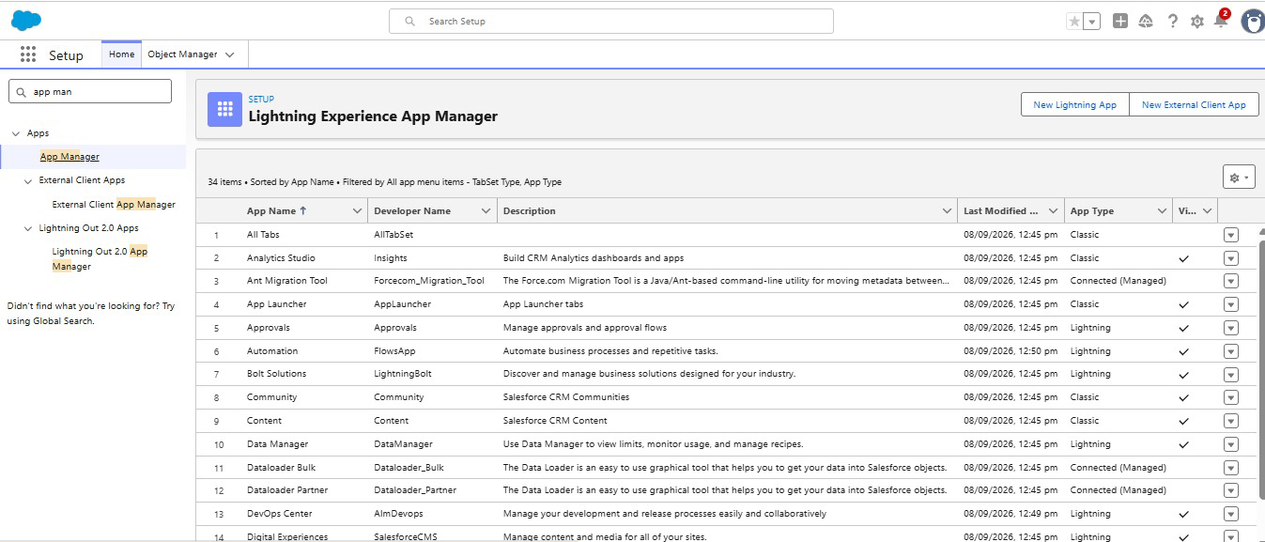
- In Setup, type "App Manager" into Quick Find and pick App Manager.
- Click New Lightning App. Enter "Farm Management System" as the App Name, then click Next.
- Beneath App Options, keep the default selections and click Next.
- Beneath Utility Items, leave things as they are and click Next.
- From Available Items, pick Farm, Crop, Farmer, Buyer, Reports, and Dashboards, and shift them into Selected Items. Click Next.
- From Available Profiles, pick System Administrator and shift it into Selected Profiles. Click Save & Finish.
- To confirm your changes, click the App Launcher, type "Farm Management System", and pick the Job Application app.
Note:
- App Launcher – Shows the apps that are available.
- App Name – Shows the app currently selected.
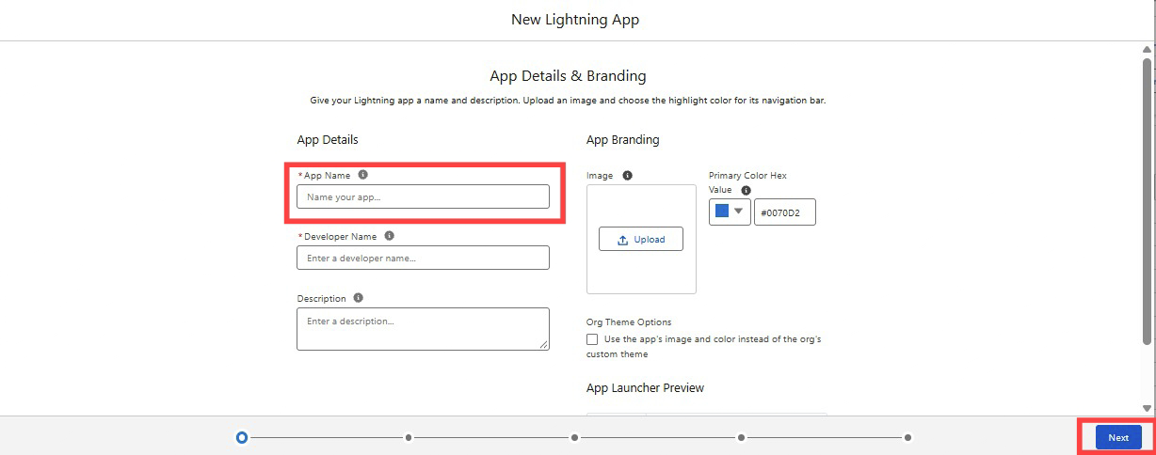
- Navigation menu – Shows the tabs contained within the app.

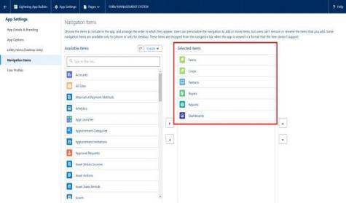

Milestone 5 – Fields and Relationship
What are fields?
Fields in Salesforce map to what columns represent in relational databases. A field holds data values that a particular object needs within a record.

Activity 1: Creation of fields for the Farm object
- Click the gear icon and pick Setup. Setup opens in a new tab.
- Click the Object Manager tab next to Home.
- Pick Farm.
- Pick Fields & Relationships from the left navigation, then click New.
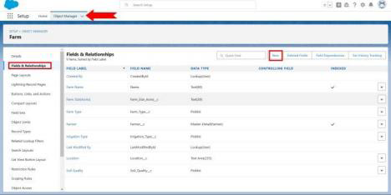
- Choose the data type as Picklist, then click Next.

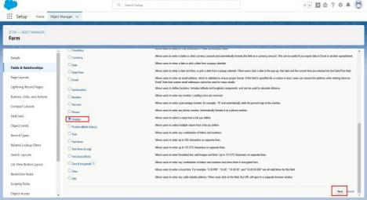
- Enter the Field Label (Farm Type) and enter values as (Crop, Livestock, Mixed).
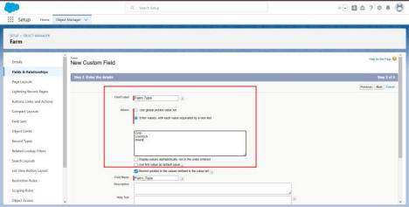
- Click Next, Next, then Save.

Now let's build the remaining fields by following steps 1 to 4 of Activity 1, selecting the data types with care.
- Build another Picklist field. Enter the field label (Soil Quality) and values (Organic, Cover Crops, Composting).
- Build another Picklist field. Field Label (Irrigation Type), enter values (Sprinkler irrigation, Drip irrigation, localized irrigation).
- Choose the data type as Text and enter the field label (Location).
- Choose the data type as Text and enter the field label (Size).
- Build a Master-Detail relationship with the Farmer object.

Activity 2: Creation of fields for the Crop object
- Choose the data type as Text, enter the field label (Crop Name), Next, Save.
- Pick the data type as Date, enter the field label (Planting Date), then Save.
- Once more pick the data type as Date, enter the field label (Harvest Date), Save.
- Build a Lookup relationship on the Crop object tied to the Farm object.
- Pick the data type as Currency, enter the field label (Actual Yield), Next, Save it.
- Pick the data type as Number, enter the field label (Total Acres Harvested), enter Maximum Length (20), and Save.
- Now build a Formula field. To do that, pick the data type as Formula and click Next.
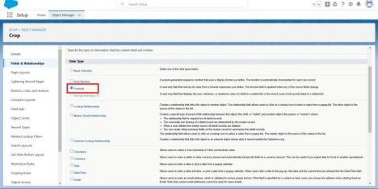
- Enter the field label (Expected Yield per Acre), pick formula return type as Currency, click Next.
- Enter the formula: Actual Yield divided by Total Acres Harvested, then click Next and Save.
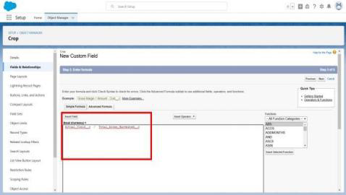

Activity 3: Creation of fields for the Farmer object
- Pick the data type Phone, enter the field label (Contact Number), Next, Save.
- Pick the data type Picklist, enter the field label (State), enter values (Telangana, Andhra Pradesh, Tamilnadu), Save.
- Choose the data type Picklist, enter the field label (District), enter values of districts, Next, Save. 4. Once more pick the data type as Picklist, enter the field label (Village), enter values of villages, Next, Save.
Creation of field dependency
- Now build a field dependency for the District field. Open Object Manager, choose the Farmer object, pick Fields & Relationships; on the right side the Field Dependency option will appear — pick it.
- Click New, pick the controlling field as State and the dependent field as District, then click Continue.
- Pick the suitable value in each column by double-clicking them.
- For instance: Telangana – Yadadri Bhongir.
- Click Include Values. Do the same for Andhra Pradesh and Tamilnadu together with their cities.
- Click Preview, then test the dependency by picking a different State and viewing the values tied to that particular state.
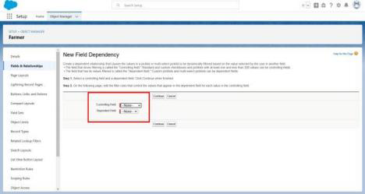
- Click Close to shut the preview window, then click Save.
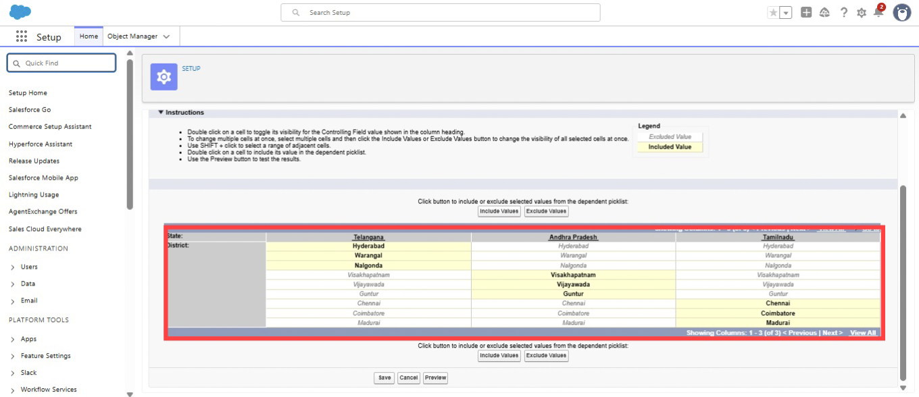

Activity 4: Creation of fields for the Buyer object
- Pick the data type as Phone, enter the field label (Contact), Save.
- Pick the data type as Email, enter the field label (Email), Next, Save.
- Pick the data type Text Area, enter the field label (Address), Save it.
- Pick the data type Picklist, field label (Buyer Type), enter values (Wholesale, Retail), click Save.

Milestone 6 – Profile
What is a profile?
A profile is a grouping of settings and permissions that determines what a user is able to do in Salesforce. A profile governs object permissions, field permissions, user permissions, tab settings, app settings, Apex class access, Visualforce page access, page layouts, record types, login hours, and login IP ranges.
One profile may be assigned to many users, though a user can hold only one profile at any given time.

Activity 1: Create a custom profile
- In Setup, type "profiles" into the Quick Find box.
- Pick Profiles (Standard User).
- Click Clone.
- For Profile, enter Sales Department.

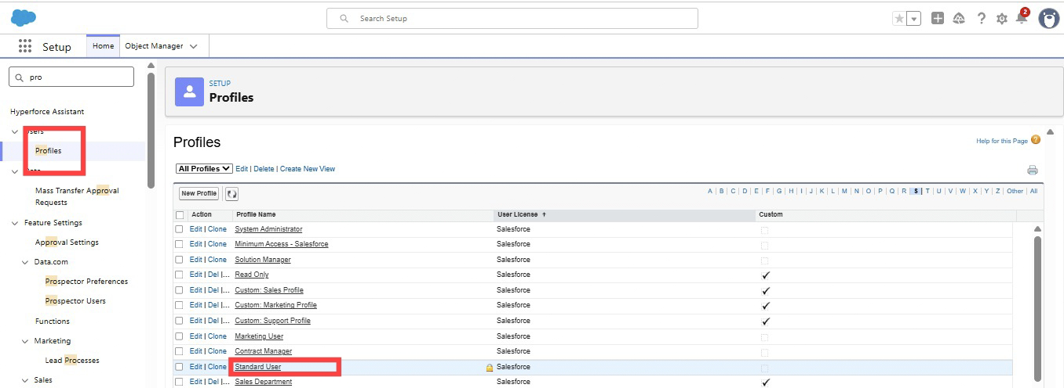

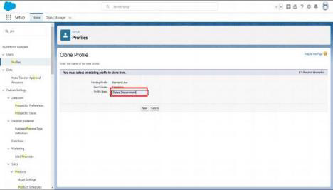

- Click Save.

Activity 2: Create a custom profile-2
Build a profile named "Farm Manager".
- In Setup, type "profiles" into the Quick Find box.
- Pick Profiles (Standard User).
- Click Clone.

Milestone 7 – Role
In Salesforce, roles decide which users can reach certain data and functions inside the system. They also establish the reporting hierarchy within an organization. Users holding higher roles gain broader data access and more control over the system.

Activity 1: Creation of role
- From the Quick Find box, search for "role" and click the Roles option.
- Pick the Set Up Roles option.
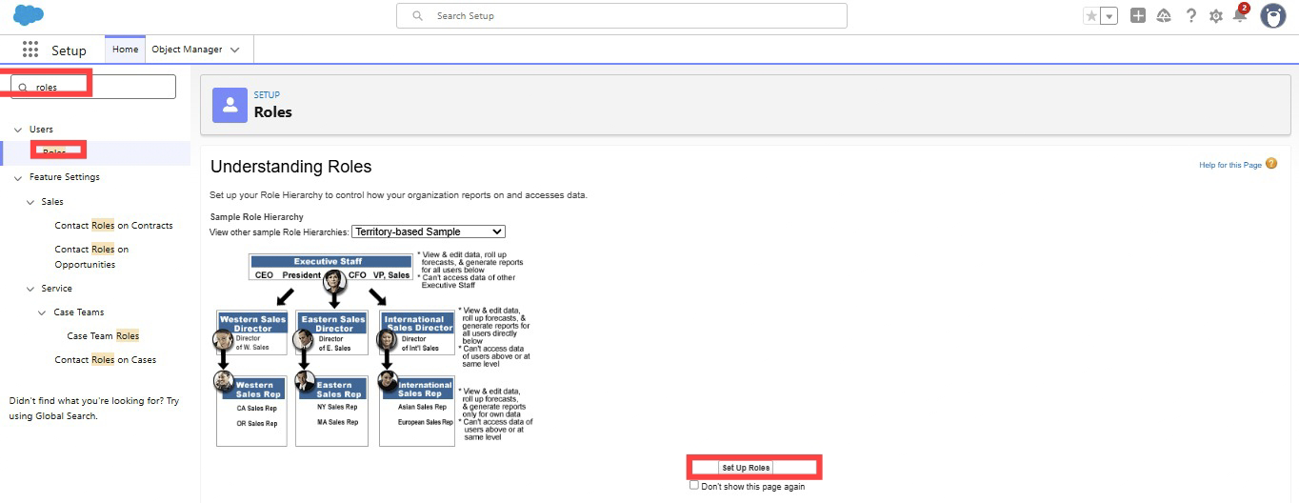
- Below CEO, click Add Role, enter the label name as "Farm Manager" — the role name will fill in automatically — then click Save.

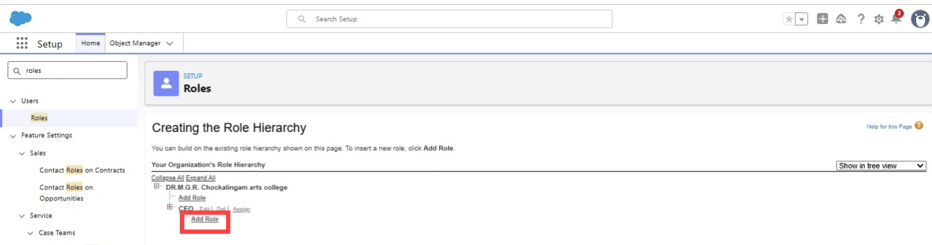

Milestone 8 – User
What is a user?
A user is anybody who logs into Salesforce. Users are employees at your company — sales reps, managers, IT specialists, and others — who require access to the company's records. Each user in Salesforce holds a user account. That account identifies the user, and its settings determine which features and records the user may access.
NOTE: A Salesforce license can only be used by 2 users at a time in a Dev Org. Therefore, if no Salesforce license is available, deactivate a user who already holds one, or switch that user's license type from Salesforce to another type.

Activity 1: To create a user
- In Setup, type "Users" into the Quick Find box, then pick Users.
- Click New User.
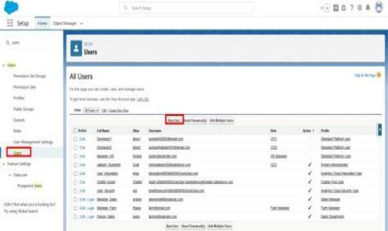
- Enter the First name as Farm and the last name as Manager.
- Enter the user's name, email address, and a unique username in the form of an email address. By default, the username matches the email address.
- Pick the role Farm Manager.
- Pick the user License as Standard Platform User.
- Pick the profile (Farm Manager).
- Click Save.
Activity 2: Build a user with the username "Sales Department" and assign that user the Sales Manager profile. Follow the steps from the Activity above.

Milestone 9 – Sharing Rules
What are Sharing Rules?
Sharing rules allow users to share records according to conditions. They are mainly created for objects whose organization-wide defaults (OWD) are set to public read-only or private, since sharing rules can only widen access — they cannot narrow it.
Types of sharing rules:
● Owner-based Sharing Rules ● Criteria-based Sharing Rules

Activity 1: Create a sharing rule
- Go to Sharing Settings, which sits under the Quick Find section.
- Scroll down to locate the object where a sharing rule is needed, then click New to build a new sharing rule.
- Add the label of the sharing rule you intend to create.
- Pick your rule type according to the criteria.
- Pick the field "can join immediately" — check the field from the Crop object.
- Pick Crop as equal and the value as True.
- In the "select the users to share with" section, pick roles and, within that, pick Farm Manager.
- In the "select the level of access for the users" section, grant Read/Write access.
- Save the rule.
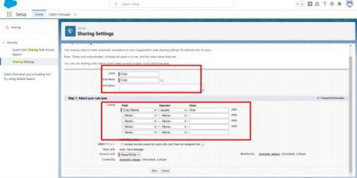
Activity 2: Build a sharing rule to share the records of Buyer with the Sales department with Read/Write access. Follow the steps from the Activity above.

Milestone 10 – User Adoption

Activity 1: Create a Record (Farmer)
- Click App Launcher on the left side of the screen.
- Search for Farm Management and click it.
- Click the Farmer tab.
- Click New, fill in the details, and Save.
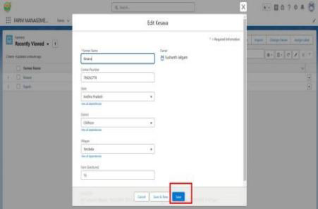

Milestone 11 – Reports
What are Reports?
A report is a list of records that satisfy the criteria you set. It appears in rows and columns and may be filtered, grouped, or shown as a graphical chart. Each report is kept in a folder. Folders may be public, hidden, or shared, and can be set to read-only or read/write.

Activity 1: Create a report
Build a report that shows the rating of the account and which has type and account name.
- Click App Launcher and search for Reports.
- Click New Report and pick the category Farmer with Farms.
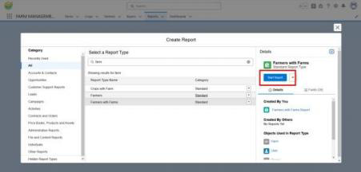
- In the Details section, pick the option Start Report.
- In Outline, click Columns and pick which fields you want to display in the report.
- Click Group and pick which fields you want to group.
- Save the report by giving it the label name (Farmer with Farms), save it into a public folder, and save the report.
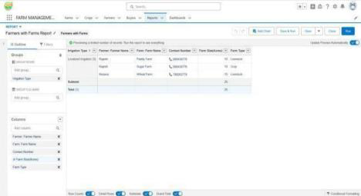
Activity 2: Build a report using the objects Crops and Buyers. Follow the steps from the Activity above.

Milestone 12 – Dashboard
Dashboards give deeper insight than reports since they merge data from numerous reports and present a summarized result. Looking at several reports at once offers the flexibility of combining their results quickly. Summaries in dashboards also help in settling on action plans faster. Dashboards may hold charts, graphs, and tabular data.

Activity 1: Create a Dashboard
- Click the Dashboard tab.
- Click New Dashboard.
- Name the dashboard "Farmers with Farms" and click Create.
- Click +Component.
- Pick "Farmers with Farms" and click Select.
- Pick the Gauge chart and click Add.
- Click Save and then Done.
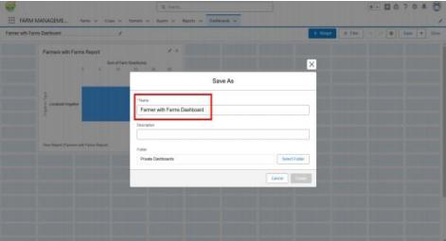

Milestone 13 – View Report and Dashboard

Activity 1: Report
- Click App Launcher on the left side of the screen.
- Search for Farm Management System and click it. ● Click the Reports tab.
- Click "Farmers with Farms" and view the records.
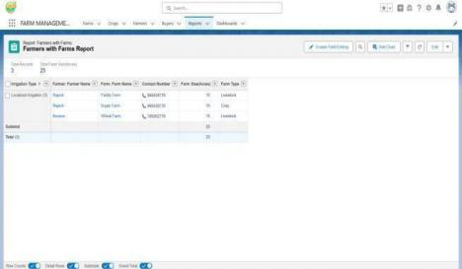

Activity 2: Dashboard
- Click App Launcher on the left side of the screen.
- Search for Farm Management System and click it. ● Click the Dashboard tab.
- Click "Farmers with Farms" and view the records.
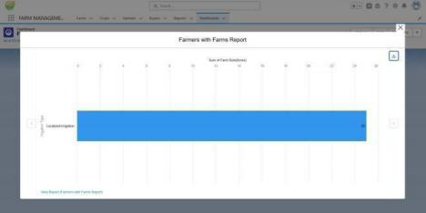

7. FUNCTIONAL & PERFORMANCE TESTING
Throughout the testing phase, screenshots were taken from the Salesforce interface to confirm system functionality. The following were put through testing:
- Creation of Farm, Crop, Farmer, and Buyer records
- Validation of input fields
- Relationship and dependency checks
- Profile and role access testing
- Sharing rule verification
- Report and dashboard generation
Performance testing verified that the system responded smoothly and stayed stable while multiple users carried out operations.

8. ADVANTAGES & DISADVANTAGES

Advantages
- Improved data accuracy – Validation rules stop incorrect or incomplete entries right at the point of entry.
- Better monitoring – Managers can follow farm productivity and sales performance as they happen.
- Real-time analytics – Reports and dashboards hand over instant insight for quicker decisions.
- Role-based security – Profiles, roles, and sharing rules keep sensitive data away from unauthorized users.
- Scalability – Cloud infrastructure can take on more farms, users, and regions with little rework.
- Automation of routine tasks – Flows and validation rules cut down manual effort and human error.

Disadvantages
- Requires internet connection – Without an active internet connection, the system cannot be used.
- Salesforce license dependency – Ongoing use hinges on Salesforce licensing and subscription costs.
- Limited offline access – Offline data entry and synchronization are not supported natively.
- Steep learning curve – New users, particularly farmers, may require training to move around the Salesforce interface.
- Customization limits – Complex needs may call for Apex/Visualforce coding that goes beyond declarative tools.
- Initial setup cost and time – Setting up objects, fields, relationships, and security demands considerable upfront effort.

9. Conclusion
The Farm Management System has effectively brought agricultural data management into the digital space using Salesforce. By gathering information on farms, crops, farmers, and buyers into one place, it removes the inefficiencies that come with manual record-keeping and keeps data accurate through validation rules, relationships, and role-based access control. Live reports and dashboards then let farmers and managers track productivity, follow sales, and reach informed decisions quickly. Every planned milestone — from object creation and field configuration through profiles, roles, sharing rules, reports, and dashboards — was finished and tested for functionality and stability. On the whole, the system cuts paperwork, reduces errors, lifts efficiency, and lays a scalable groundwork for future additions such as mobile integration, AI-based crop prediction, and IoT connectivity.

10. FUTURE SCOPE
- Mobile application integration – Take the FMS onto Android and iOS so farmers can reach and update records straight from the field.
- AI-based crop prediction – Apply machine learning to estimate crop yields and suggest the most suitable crops using soil, season, and past data.
- Weather data integration – Hook up live weather APIs to deliver forecasts, rainfall alerts, and irrigation advice.
- IoT sensor connectivity – Connect soil moisture, temperature, and humidity sensors for continuous, automated farm monitoring.
- Market price forecasting – Offer live mandi/market price trends and predictive pricing so farmers can sell at the right moment.
- Multi-language and voice support – Introduce regional language interfaces and voice input so farmers with limited literacy can operate the system with ease.

11. APPENDIX
- Source Code: Salesforce Configuration and Metadata
- Dataset: Farm, Crop, Farmer, and Buyer Records
- Tools Used: Salesforce Developer Org

Thank You

